
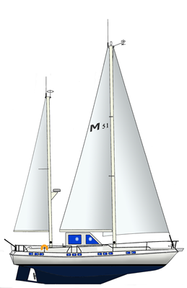
CREW LIST

S/Y LAYA
Callsign/Registry: SDAI

Port of registry: Huskvarna, SWEDEN
Dimensions: 15,78M 4,53M 1,70M
Gross/Net Ton: 20/6
Engine: Volvo Penta, 130 h.p. No: XXXXXXXXX
Hull: Plastic, White, HIN: XXXXXXXXX
MMSI nr: 265671260
Insurance: Pantaenius , Policy no. XXXXXXXXXXXX

Name | Position | Birth Date | Place of birth | Nationality | Passport nr
Hans Gustav  Palmberg | Skpper |  |  | Swedish
Agneta Astrid Cecilia Palmberg | Crew |  |  | Swedish
 | Crew |  |  | Swedish
 | Crew |  |  | Swedish
 | Crew |  |  | Swedish
 | Crew |  |  | Swedish

Residence: Hans Palmberg
Kålgårdsgatan 7
553 24 Jönköping
SWEDEN

Date: _______________________________________

Signed: _____________________________________
Hans Palmberg / Skipper S/Y LAYA

